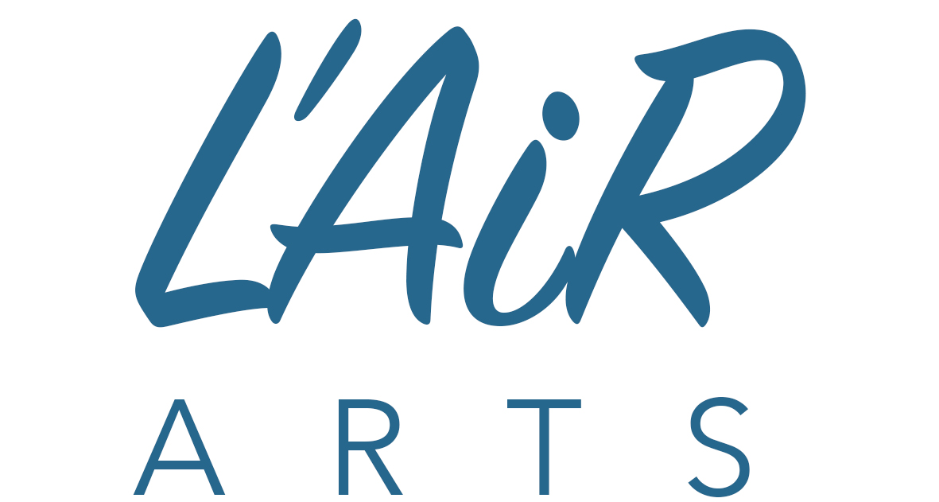

International artist residency - paris, France
what’s on: October 16 – 30, 2018
In addition to our group programming and to help you explore independently during the residency, we’ve put together a list of exhibitions on view at the main art galleries and museums in Paris. Please note, not all the following institutions are part of the Paris Museum Pass. Also, the Pass only gives access to the permanent collections, not special exhibitions. For more information about the Pass, please visit: http://en.parismuseumpass.com

MUSEUM OF MODERN ART - “Somewhere in the Desert” by Israeli photographer Ron Amir presented at the Israel Museum in Jerusalem in 2016.
Tuesday to Sunday from10 am at 6 pm (last entry 5:15); Nocturne on Thursdays until 10 pm for temporary exhibitions (last entry 9:15 pm)
Free entry for permanent collections
12-14 avenue New York 75116 Paris

MUSEUM OF DECORATIVE ARTS – Tutto Ponti, a first retrospective in France of architect-designer Gio Ponti. From October 19, 2018.
Tuesday to Sunday 11 am to 6 pm (last entry 5:15 pm); on Thursdays from 11 am to 9 pm (last entry 8:15 pm)
107-111, rue de Rivoli, 75001 Paris

CENTRE POMPIDOU - On the occasion of the France-Israel season, the Center Pompidou presents Thicket by the artist Maya Dunietz, an installation composed of 10,000 earphones composing a huge "acoustic cloud" at the crossroads of sound and image.
- TADAO ANDO - THE CHALLENGE - Retrospective dedicated to the great Japanese architect (born in 1941 in Osaka), famous for its sober and refined aesthetic, awarded with many prizes, including the Pritzker in 1995.
- FRANZ WEST - The largest retrospective devoted to the work of the Austrian artist Franz West (1947-2012).
- MARCEL DUCHAMP AWARD 2018 - Exhibition of the four finalists of the Marcel Duchamp Prize, one of the most prestigious contemporary art awards in the world, focusing on the French art scene. This year: Mohamed Bourouissa, Clement Cogitore, Thu-Van Tran and Marie Voignier.
See also a presentation of Centre’s modern collections, from 1905 to 1965; and a presentation of contemporary collections (from the 60s)
Every day except Tuesday from 11 am to 9 pm (Thursday to Sunday permanent collections open until 11 pm); Brancusi Atelier 2 pm – 6 pm
Place Georges Pompidou, 75004 Paris

LOUIS VUITTON FOUNDATION - Jean-Michel Basquiat & Egon Schiele: from one end to the other of the twentieth century, from Europe - Vienna - to America - New York, the works and lives of Egon Schiele and Jean-Michel Basquiat.
Every day except Tuesday (Monday, Wednesday and Thursday from 11 am to 8 pm; Fridays from 11 am to 9 pm - nocturnal until 11 pm; Saturday and Sundays from 9 am to 9 pm)
8, Avenue du Mahatma Gandhi Bois de Boulogne - 75116 – Paris

FONDATION CARTIER POUR L’ART CONTEMPORAIN - the exhibition Géométries Sud, Du Mexique à la Terre de Feu, celebrates the wealth and colors of the motifs, forms and gures present in Latin American art.
Every day except Monday from 11 am to 8 pm; Tuesdays until 10 pm
261, Boulevard Raspail, 75014 Paris, France

GRAND PALAIS – Miró. Bringing together nearly 150 works, some of them unpublished in France and covering 70 years of creation, this retrospective retraces the technical and stylistic evolution of the artist.

Every day except Tuesdays; Thursday, Sunday and Monday from 10 am to 8 pm; Wednesday, Friday and Saturday from 10 am to 10 pm.
From October 20 to November 3 from 10 am to 10 pm; early closing at 8 pm on Thursday, October 25th.
3, avenue du General Eisenhower, 75008 Paris

JEU DE PAUME - "Dorothea Lange. Visible Politics”, featuring major works by world-renowned American photographer Dorothea Lange; “Time and history overlap me”: first major museum exhibition devoted to filmic work of an internationally recognized Cuban-American artist, Ana Mendieta.
Every day except Mondays - Tuesday from 11 am to 9 pm; Wednesday to Sunday from 11 am to 7 pm.
1 place of the Concorde, 75008 Paris – access by the Tuileries Garden, from Rivoli street.

MUSÉE MAILLOL – “Giacometti: Between tradition and avant-garde.” Produced in collaboration with the Fondation Giacometti, Paris, the exhibition presents more than 50 sculptures of the artist, compared with nearly 25 works by other great classical sculptors and modernists of his time, such as Rodin, Bourdelle, Maillol, Despiau, Brancusi, Laurens, Lipchitz, Zadkine, Csaky or Richier.
Every day from 10:30 am to 6:30 pm; Nocturnal on Friday until 8:30 pm. Last admission 30 minutes before the museum closes.
61 rue de Grenelle 75007 Paris

MUSEUM MARMOTTAN MONET – “Private Collections: A Journey from Impressionists to Fauves”, will gather about sixty works from exclusively private collections from around the world. These rarely shown before masterpieces, include works by Monet, Degas, Caillebotte, Renoir, Rodin, Camille Claudel, Seurat, Signac, Gauguin, Van Gogh, Derain, Vlaminck and Matisse.
Tuesday to Sunday from 10 am to 6 pm (last admission5:30 pm); Nocturnal Thursdays until 9 pm (last admission 8:30 pm)
2, rue Louis-Boilly, 75016 Paris

MUSÉE D'ORSAY – “Picasso. Blue and pink.” Exhibition dedicated to the blue and pink periods of Pablo Picasso. Presented in collaboration with the Musée National Picasso-Paris.
Tuesday to Sunday from 9.30am to 6pm; nocturnal Thursday open until 9.45pm
1, rue de la Legion d'Honneur, 75007 Paris

PALAIS DE TOKYO – “Carte Blanche in Tomás Saraceno. On air”. Largest project ever made by Tomás Saraceno, whose research is developing at the crossroads of arts, science and architecture, the carte blanche brings together a selection of his major works as well as ambitious new productions that transform the Palais from Tokyo into a unique sensory space.
Every day except Tuesdays from noon to midnight.
13, avenue du Président Wilson, 75116 Paris

MUSÉE NATIONAL PICASSO - “Masterpieces” The exhibition brings together some of the greatest works from all over the world, displayed alongside those from the museum collection.
Tuesday – Friday: 10.30 am – 6 pm; Saturdays and Sundays: 9.30 am – 6 pm; During French school holidays: Tuesday – Sunday: 9.30 am – 6 pm
5 rue de Thorigny 75003 Paris

MUSEE RODIN – “Mac Adams - Patrick Hourcade at Rodin Museum”, the exhibition by two contemporary photographers in relation to Rodin’s works.
Every day except Mondays from 10 am to 5.45 pm. Last entry at 5.15pm
77 rue de Varenne, 75007 Paris, France

MUSEE ZADKINE – “Ossip Zadkine - The Instinct of the Matter”. Marking the 130th anniversary of Ossip Zadkine, the museum pays tribute to the artist.
Every day except Monday from 10 am to 6 pm. Last entry 5:40 pm
Free entry for permanent collections
100 bis, rue d'Assas, 75006 Paris

Open on Mondays
Although most of the museums are closed on Mondays, below is the list of places that are open either every day or closed on Tuesdays instead. Less crowds too! A tip from our art historian: if you wish to visit Louvre, best time to go is between 12 noon and 2 pm.
- Louvre
- Centre Pompidou
- Gustave Moreau Museum
- Eugène-Delacroix Museum
- Orangerie Museum
- Sèvres – National Ceramic Museum
- Grand Palais
- Luxemburg Museum
- Musée Maillol
- Louis Vitton Foundation
- Palais de Tokyo
- Claude Monet Foundation - Giverny (every day from March 23 to November 1)

For the list of all the major Parisian exhibitions, visit: https://en.convention.parisinfo.com/latest-news/agenda/major-exhibitions

For all the other events in Paris please visit www.offi.fr. You can download the L'Officiel des Spectacles app, it’s free and available on iPhone and Android.

